2022(Odd)
Time .• 3Hrs. Sem - 111/CSE
CPTC
Full Marks : 70
Pass Marks : 28
Answer all 20 questions from Group A, each question
carries I marks.

20 1 I
Answer all Five questionsfrom Group B, each question
carries 4 marks.
Answer all Five questionsfrom Group C, each question carries 6 marks.
All parts ofa question must be answered at one place in sequence, otherwise they may not be evaluated.
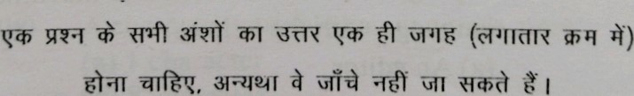
Thefigure in right hand margin indicate marks.
P.T.o
2000302 2 NT3002

GROUP-A
1. Choose the most suitable answer from the following
options : Ix20=20
fòTÙ
- C can be used on:
  - Only MS -DOS operating system
  - Only Linux operating system
  - Only windows operating system
  - All of the above
(i) 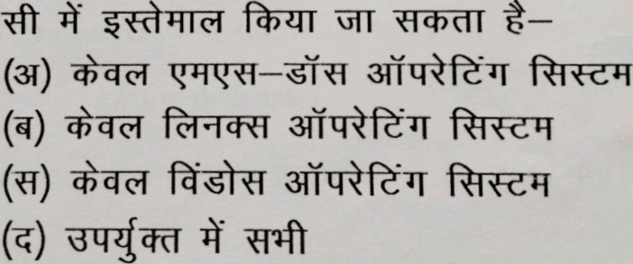
fòuT
- C programs are converted into machine language with the help of: (a) An editor
  - An operating system
  - A compiler the above
NT3002
(ii) 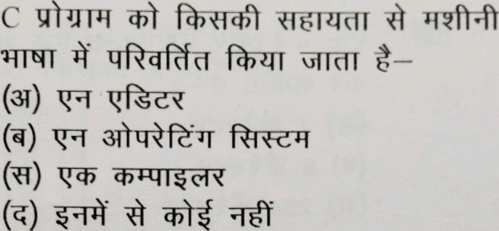
- The real constant in C can be expressed in which of the following forms: (a) Exponential form only
  - Fractional form only
  - ASCII from only
  - Both fractional and exponential forms
(iii) 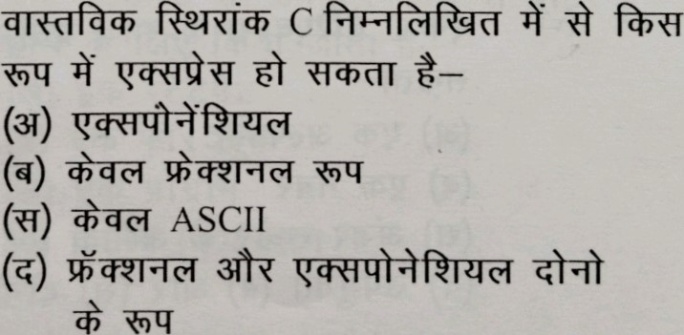
- A character variable can at a time store:
  - 1 character
  - 8 character
  - 254 character these
(iv) 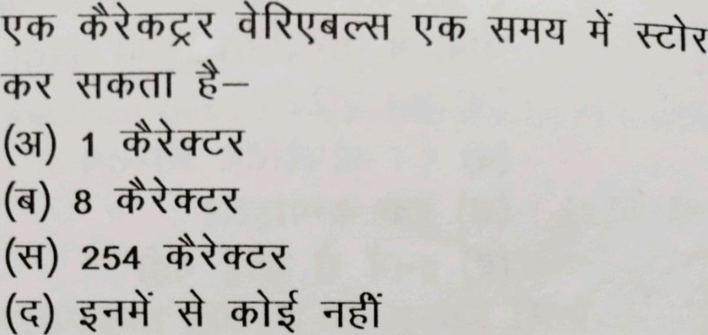
- A C variable cannot start with:
  - An alphabet
  - A number
  - A special symbol other than underscore
  - Both (b) & (c) above
(v) 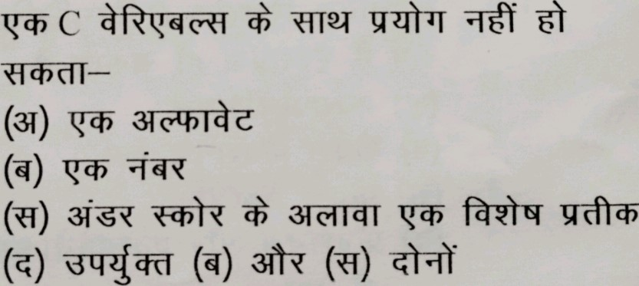
- Which of the following is allowed in a C arithmetic instruction: the above
NT3002
(vi) 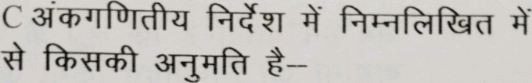
(31) [1
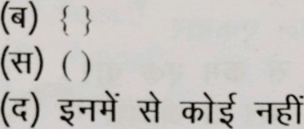
- The break statement is used to exit from: (a) An if statement
    - A for loop
    - A program
    - The main ( ) function
(vii) 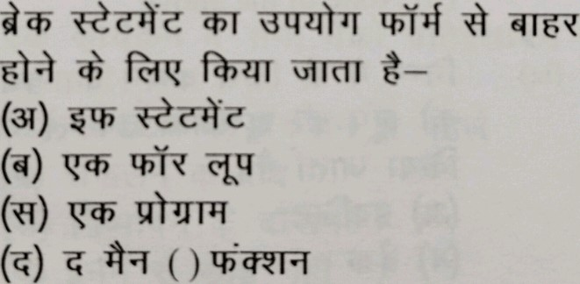
- A do-while loop is useful when we want that the statements within the loop must be executed: (a) Only once
    - At least once
    - More than once
    - One the above

NT3002
(viii) 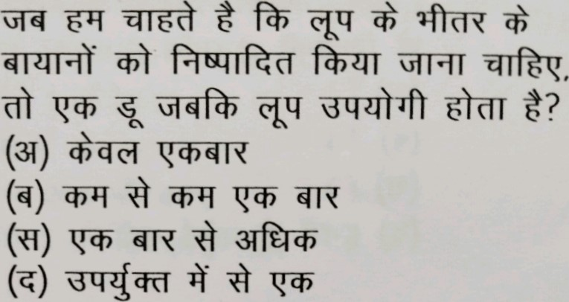
- Which of the following statement is used to take the control to the beginning of the loop. (a) Exit
  - Break
  - Continue
  - None of the above
(ix) 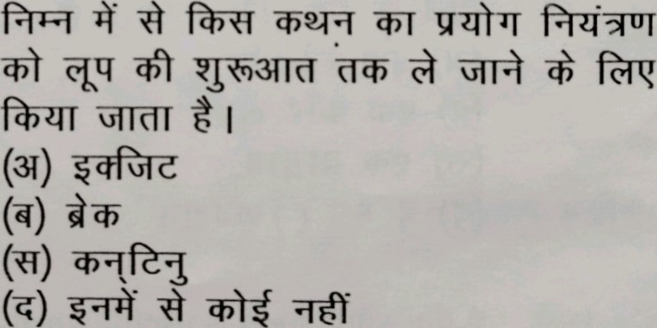
- Which of the following is not a preprocessor directive: (a) #if
  - #elseif
  - #undef
  - #pragma

NT3002
(x) 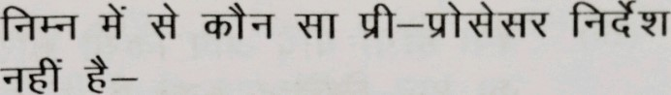
(31) #if
(q) #elseif
(O #undef
#pragma
- All macro substitutions in a program are done:
    - Before compilation of the program
    - After -compilation
    - During execution
    - None of the above
(xi) 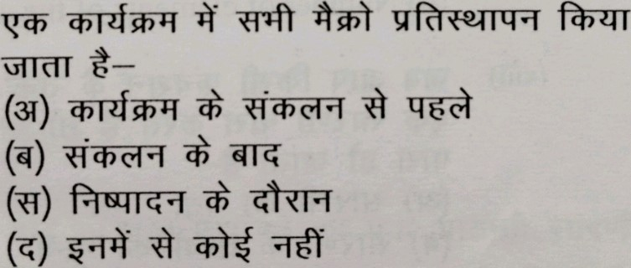
- What will happen if you assign a value to an element of an array whose subscript exceeds the size of the array? (a) The element will be set to 0
    - Error message from the compiler
    - Other data may be overwritten
    - None of the above
NT3002
(xii) 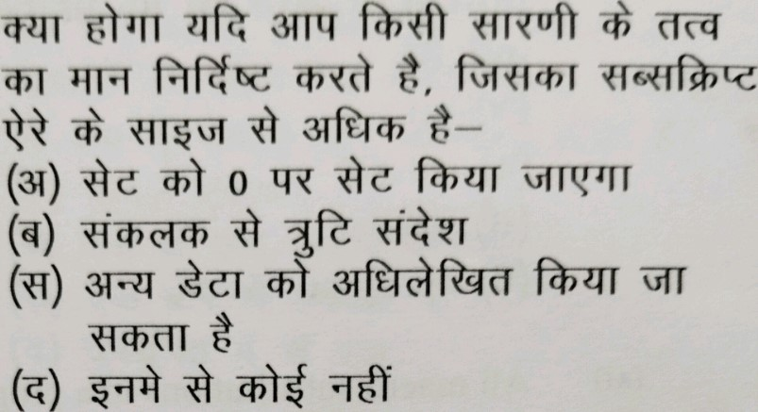
- When you pass an array as an argument to a function, what actually gets passed? (a) Address of the array
  - Values of the elements of the array
  - Address of the first element of the array
  - Number of elements of the array
(xiii) 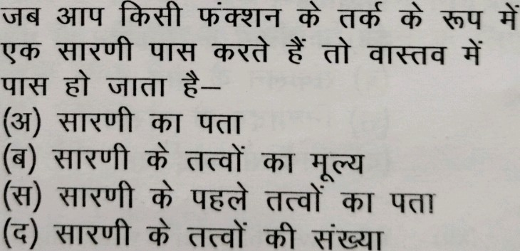
- If you don't initialize a static array, what would be the element set to?
  - An undetermined value
  - A floating point number
  - The character constant ¹/0'
NT3002
(xiv)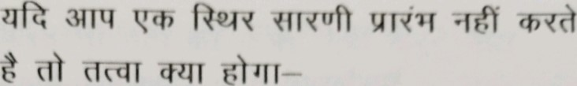
(31) o
@ 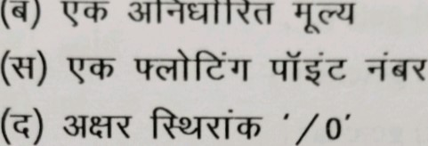
31fàuiÑ@T
- If int S[5] is a one -dimensional array of integers, Which of the following refers to the third element in the array?
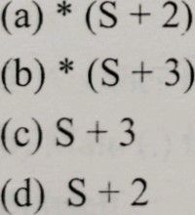
(xv) 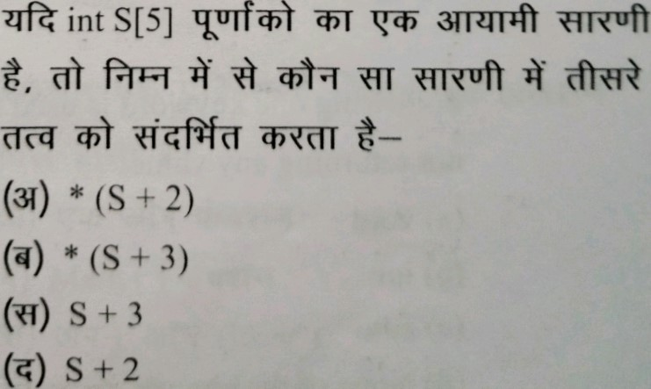

NT3002
- If an integer is to be entered through the keyboard, which function would you use?
  - scanf( )
  - gets ( )
  - getche ( )
  - getchar ( )
(xvi) 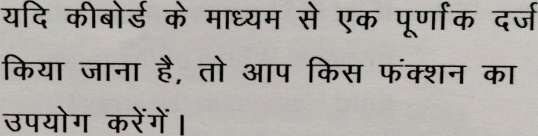
(31) scanf( )
(q) gets ( )
(NI) getche ( ) getchar ( )
- Following one keyword is used for function not returning any value. (a) void
  - int
  - auto
  - None of the above

NT3002
(xvii) fòNíÌ 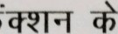fàg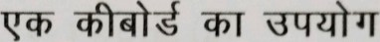

fòul a—
(31) void (q) int
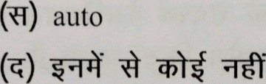
- Recursion is a process in which a function calls:
    - Another function
    - Main ( ) function (c) Itself
(d) None of the above
(xviii) 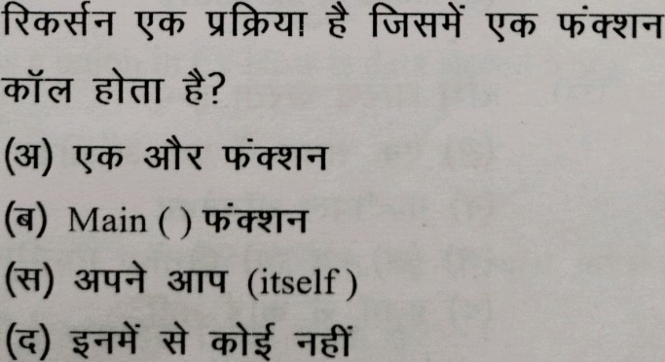
- The member variable of a structure is accessed by using: (a) arrow (+) operator
  - dot (.) operator
  - asterisk(*) operator
  - ampersand (&) operator
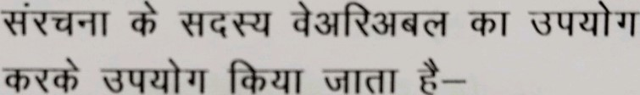
(xix) fàÑIT
(31) arrow operator
(q) dot operator
(O operator
(q) ampersand (&) operator
(xx) The union holds:
  - One object at a time
  - Multiple objects
  - Both (a) and (b)
  - None of the above
(xx) 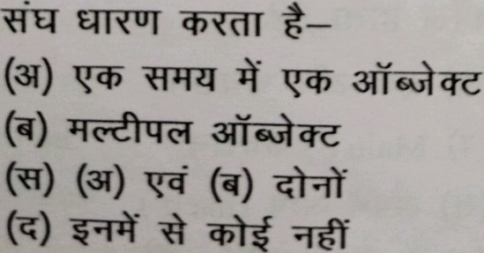
NT3002

GROUP B
Answer all Five Questions.
4x5=20
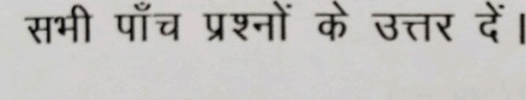
2. What is a structure in C? How is a structure declared? 4

Eùfà@T 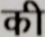
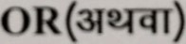
What is a union in C? How is data stored using union?

NT300
- Explain lifetime and visibility of a variable.
4
brief.
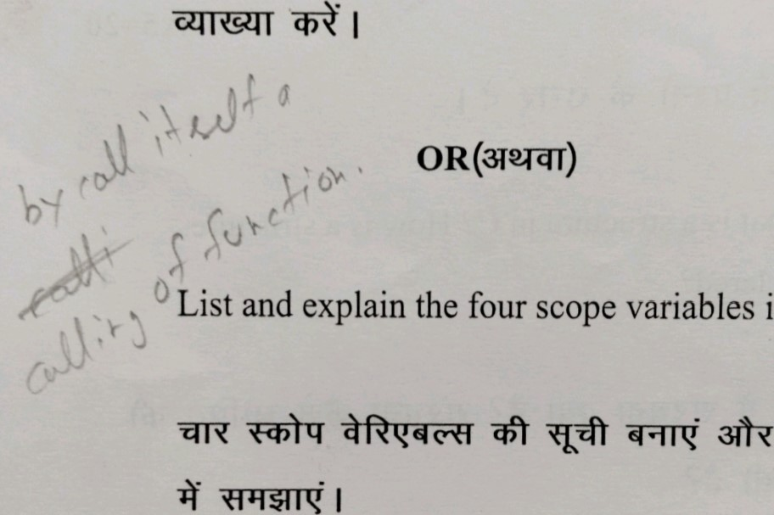
Niàq
in
- How do functions help to reduce the program size?
4
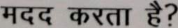
NT3002
O R (312441)
Differentiate between library and user defined functions.
- What are the actual and formal arguments?
4
OR(3T2ÃT)
Explain the types of recursion.

NT30
6. What is the main ( ) function in C? Why is it
necessary in each program? 4
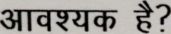
OR(312.Ãr)
Mention differences between character array and integer array.
ÄUf
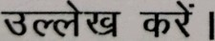
NT3002

GROUP -C
Answer all Five Questions .
6x5=30
- Write a program to demonstrate the use of three dimensional array.
6
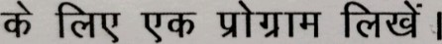
OR(312ÄÄT)
Write a program to perform addition and subtraction of two matrices whose orders up to 10 x 10.
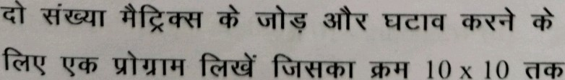 t?
10
10
P.T.O
NT300
- Compute the factorial of a given number using the do-while loop.
6
do-while
I
OR (3124ÄT)
Write a program to enter a number through keyboard and find the sum of its digits.
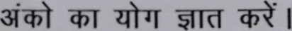
- Write a program to calculate bill of internet browsing the condition are given below.
  - I hours - 20 Rs.
  - 1/2 hours - 10 Rs.

NT3002
(c) unlimited hours in a day - 90 IQs. Owner should enter number of hours spent by customer.
6
(31) 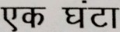 - 20 Rs. (q) 1/2 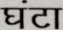- 10 Rs. (O
à-
90
Rs
q--of I
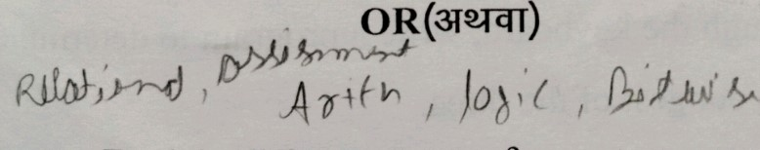, 4-n( 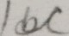Explain different types of operators supported by C.
'C' 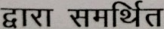 fàfrFT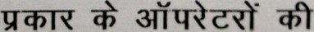
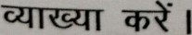
¹ 0. Elaborate different sections of a C program. 6
C fàfìFGT 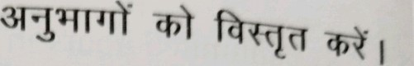
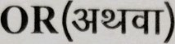
Describe the various functions used for memory allocation.
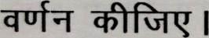
11. If the ages of Ram, Shyam and Ajay are input through the keyboard, write a program to determi the youngest of the three.
6
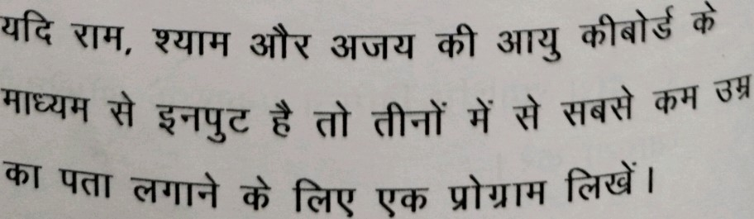
2000302

NT3002
OR(312ÄÄT)
Write a program to calculate the perimeter and area of rectangle & circle.

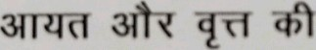qÑfù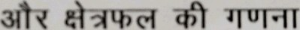
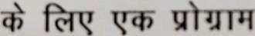 f?'Rà• I

